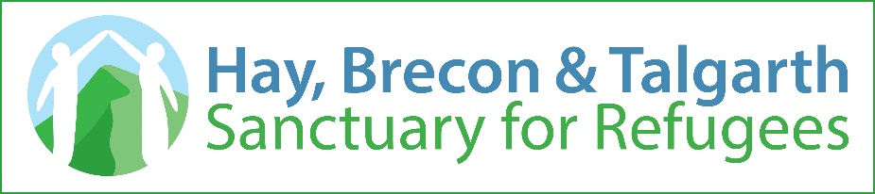

Project get together/Prosiect Gyda'ch Gilydd

Application Form for July 5,6,7th 2019
Project Get Together will involve up to 65 young people from Cardiff, Newport, Swansea and south Powys in a weekend of team building and leadership-enhancing activities. The aim of the weekend is to enable people to come together, join in interesting and enjoyable activities, and:
- Feel welcome
- Find opportunities for friendship and solidarity
- Learn to appreciate partnership and team working
- Celebrate the contribution of people from other communities, cultures and countries
The details are:
- Date & Time: 5 July 4:30 pm – 7 July 6:00 pm
- Venue: PGL Llwyn Filly near Hay on Wye, HR3 5QG
- Accommodation: in same sex dormitories and with friendship groupings
- Supervision will be provided by your group leaders or teachers and all activities will be led by experienced PGL leaders.
We hope to have some meetings in your locality before you attend the weekend and you may be asked to help raise some money towards transport and equipment.
PGL are a leading UK adventure holiday provider with years of experience of providing trips to enjoy and remember.

Please read these notes before completing

We will treat this information in strict confidence and will not share it with anyone else.

This form should be used as an Application and completed by the Candidate and their Parent or Guardian

Please use Block Capitals for names and ensure that all sections are completed clearly.

Please give an e-mail address for both the Candidate (if they have one) and Parent. Essential documents will be sent to these addresses.

Please complete the Medical Details and Consent, which will be given to staff at PGL

Please attach a photograph. No one has ever got lost but if someone does it helps to be able to show what they look like! NB this can be sent digitally….no need to print.

Please attach passport style / size photograph, here

[

Candidate Details:

Full Name: ............................................................................

Date of Birth: .............................

Age at 8 July 2019: ............................

Address: ....................................................................................

....................................................................................

Town: ............................................Postcode: ........................

Home Telephone Number: ………………………….

Mobile Number: ..................................................................

Email Address: ....................................................................

Parent/Guardian/next of kin Details:

Name: ......................................................................................................

Address (if same as candidate’s above, tick here ❑) Address: ....................................................................................

....................................................................................

Town: ............................................Postcode: ........................

Daytime Telephone Number: ………………………….

Daytime Telephone Number: ………………………….

Mobile Number: ..................................................................

Email Address: ....................................................................

Consent by Parent/Guardian [if candidate under 18]
Please note: If, in the leaders’ opinion, any young person consistently engages during the weekend in activities that cause disruption to others or disobeys clear instructions then the parent or guardian will be required to come to take the young person home.
I hereby give consent for my child to take part in Project Get Together
Signed ………………………………………………… Parent / Guardian
Date …..…………….........

Photography: as a record of the event, to report back to our funders, and to promote similar activities in future, we may wish to take some photographs and/or short videos. Would you be happy for your child to appear in these? Please indicate below. We quite understand if you prefer not to authorise this. We will do our utmost to ensure that our own volunteers comply with your wishes and will inform any outside persons (e.g. press or media). While we will also ask all the children and young people taking part (some of whom may bring their own camera or smart-phone) to be sensitive about their use of each other’s images, we cannot realistically police this.
Tick one option.
❑ I consent for my child to be photographed/videoed while taking part in Project Get Together
❑ Please do not take photographs or videos of my child during Project Get Together
Signed ………………………………………………… Parent / Guardian
Date …..…………….........

Candidate Statement
Candidate:
Please explain briefly why you would like to take part in Project Get Together. Please note that all candidates will be asked to give feedback after the event.

Why do you think it is important for young people from different communities, cultures and countries to have the chance to spend time together?

What do you think you might learn about yourself and from others attending Project Get Together?

Medical details and consent form

This form must be completed and signed by the candidate’s Parent/Guardian

Medical.

Name of Candidate: ..................................................................................

Name of Parent/Guardian: .....................................................................

Emergency phone numbers:

Day ..................................................... Evening: ......................................
I hereby give permission for any medical/hospital treatment necessary for my son/daughter whilst at Project Get together (based at PGL,Llwyn Filly).

Signed ………………………………………………… Parent / Guardian

Date …..…………….........

GP’s Name …………………………...........
Address ………………………………………………………………………………...........
Surgery Telephone Number ………………………....

Health Report:

Please circle the appropriate answer and add specific details if necessary. Llwyn Filly Adventure Centre is able to deal with common allergies, illnesses and low-level mobility issues, and different dietary requirements but they need to be notified in advance.

Please inform the Administrator when you arrive at Llwyn Filly if you have any temporary illness or if any of the statements made below need updating.

If your Tetanus inoculation is not up to date, you must ensure you get it updated before the course and confirm that you have done so.

Medical question | Y/N | Details

Do you suffer from any recurring illness

Do you take regular medication that you will need to bring to Get together?

Are you allergic to anything?

Are you unable, for health reasons, to undertake any particular activity?

Do you have any specific dietary requirements eg Vegetarian, Vegan,Halal?

Do you have an up-to-date tetanus inoculation?

Can you swim 50 metres?

Are you confident in water - to go into a river or pool with a buoyancy aid?

Do you have any disabilities or mobility issues?

