WELCOME DAY
RISK ASSESSMENT DOCUMENTATION

- This documentation must be completed by the organiser/ representative of the ‘Welcome Day’ prior to the event.

- It must be shared with the organiser/ designated volunteer from the visiting location prior to the event and all relevant information passed on to the visitors.

BUT REMEMBER RISK IS EVERYONE’S BUSINESS

COMPLETED BY: DATE:
SHARED WITH VISITING GROUP/S ORGANISER/S: DATE:
VENUE: DATE OF WELCOME DAY:
The HSE stresses that……
‘The law does not expect you to eliminate all risk but requires organisations to protect people as far as is reasonably practicable’. Assessment of risks should therefore be suitable and sufficient, not perfect.

PLEASE RISK ASSESS EACH HAZARD USING THE GRID BELOW:

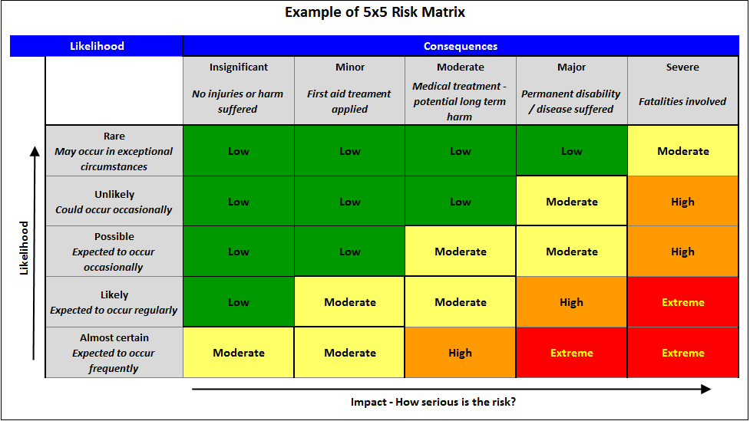
Identify potential hazards and assess the level of risk for each, then consider what action should be taken to minimise the risk and document using the form below. Information which is highlighted should be shared with visiting organiser/s.

NATURE OF RISK | LEVEL OF RISK  (see grid) | ACTION TO BE TAKEN TO REDUCE LEVEL OF RISK
GENERAL (for every Welcome Day)
Covid/ Public Health Guidance | Low - Moderate | Plan as much of the event outdoors, as is possible. For indoor activities, ventilation is very important. Open doors and windows as appropriate. All areas must be cleaned prior to the day. Individuals must be reminded to wash hands frequently. Hand sanitiser must be available. Maintain a respectable distance from visitors. Refrain from hugging.
Children left unsupervised | Low - Moderate | Parent’s are responsible for their children. If child/ren are left with volunteers then the volunteers have responsibility for the child/ren. The volunteers must remain with the child/ren until s/he has been returned to the parent/s. Volunteers are reminded of HBTSR Safeguarding Policy.
Undertaking activities outside those planned by HBTSR | Low - Moderate | The organiser of the Welcome Day should have a plan of the day with activities listed in written and pictorial format.  Visitors should take time to note the activities and ensure they understand what is being offered.  Visitors should check with the organiser of the day if they wish to do something that is not listed.
Extremes of weather – very wet, windy, cold, hot etc. | Low | The organiser of the Welcome Day should note the weather forecast prior to the day.  Activities should be planned according to weather conditions.  If the forecast is for strong winds then any tentage that needs to be erected should be done on the morning of the Welcome Day and securely tied down.  Visitors should be advised to wear appropriate clothes for the weather and activities planned.
KITCHEN AREA
INDOOR AREA
OUTDOOR AREA

ACTIVITIES

Assessment undertaken by:

Signature:

Date:

If a potential hazard is assessed as EXTREME or HIGH RISK, please inform a Trustee to ensure that all health and safety precautions have taken place before a decision can be made to authorise it. A final decision will then be made collectively.

To be completed after the Welcome Day
REVIEW OF RISK ASSESSMENT:
Did any risk incidents occur? | Who was affected? | What action was taken? | What was the outcome?

Did any queries/ concerns/ near misses occur? Please explain further.

This document must be shared and discussed at the next available HBTSR meeting and recommendations for future Welcome Days identified and recorded.

